Soft Links and Hard Links in Linux
In Linux, links are references to files. There are two main types of links: Soft Links (Symbolic Links) and Hard Links. Both serve the purpose of creating references, but they work differently at the filesystem level.

1. Soft Links (Symbolic Links)
• A soft link is more like a shortcut to the original file.
• It contains the pathname of the target file, rather than pointing directly to the inode.
• Soft links have their own inode and are independent files.
• If the original file is deleted, the soft link becomes a 'broken link'.
• Soft links can span across different filesystems or partitions.
• Can be created for both files and directories.
• To create a soft link:
ln -s original_file softlink_name

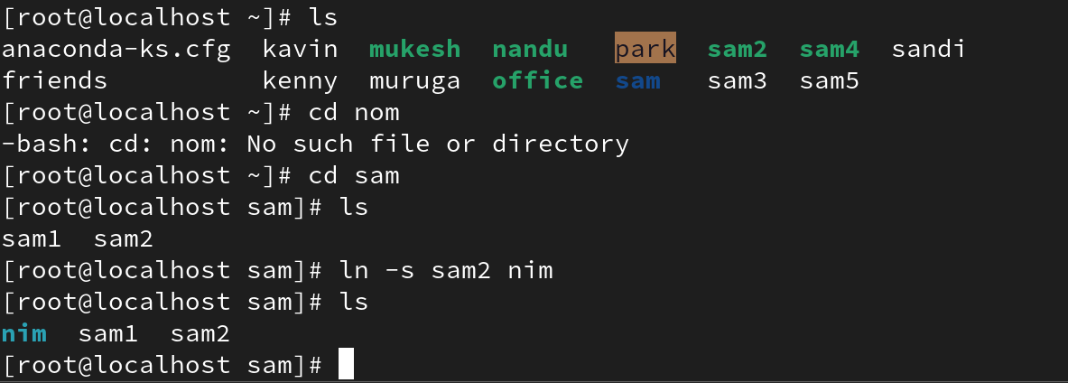

2. Hard Links
• A hard link is essentially another name for an existing file.
• It points directly to the inode of the file, meaning both the original file and the hard link share the same inode number.
• Changes made to one file are reflected in the other, since they reference the same inode.
• Deleting the original file does not remove the data as long as a hard link exists.
• Hard links cannot span across different filesystems or partitions.
• Cannot be created for directories (to prevent loops).
• To create a hard link:
ln original_file hardlink_name

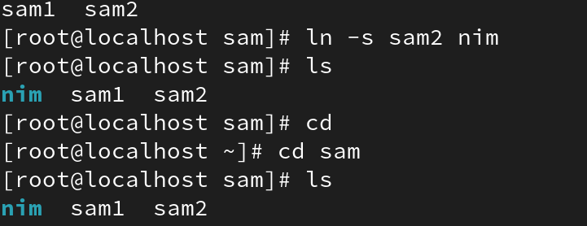

3. Key Differences
Hard Links:
- Share the same inode number as the original file.
- Cannot span across filesystems.
- Remain valid even if the original file is deleted.
- Cannot link directories.
Soft Links:
- Have a different inode number than the target file.
- Can span across filesystems.
- Become invalid if the target file is deleted.
- Can link directories.

